**Project Report : IBM Data Analytics Project**

**Title : Unveiling The Virtual Classroom: An In-Depth Analysis Of**

**The Online Education System**

**Prepared by : Dr.R.Senthilkumar, Assistant Professor, Electronics and Communication Engineering, Government College of Engineering Erode, Tamilnadu- 638316. Contact mail id: senthilkumareceirtt@gmail.com**

**Date : 20.9.2023**

**Table of Contents**

**Contents Page No.**

1. Executive Summary 2

2. Introduction 2

3. Data Collection 2

4. Data Preprocessing 3

5. Data Exploration 5

6. Data Analysis 6

7. Key Findings 7

8. Recommendations 7

9. Conclusion 8

10. Appendices 8-16

1. **Executive Summary**

This report presents the outcomes of an IBM Data Analytics project that delves into the dynamics of the online education system, aiming to provide insights into the virtual classroom's functioning. The project involved comprehensive data collection, rigorous preprocessing, thorough exploration, advanced analysis, and actionable recommendations based on the findings.

**2. Introduction**

Online education has gained tremendous prominence, especially in the wake of recent global events. Understanding the online education system's inner workings is paramount to enhancing its effectiveness. This project seeks to leverage IBM Data Analytics tools to gain valuable insights into the online education landscape. Key project objectives include:

• Analyzing student engagement and performance data.

• Identifying trends in online teaching methods.

• Providing recommendations for enhancing the virtual classroom experience.

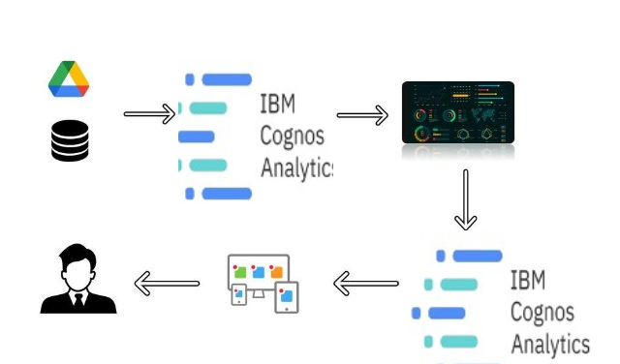

*Figure 1. Technical Architecture*

**3. Data Collection**

Data collection was conducted meticulously, encompassing a variety of sources, including online learning platforms, student performance records, and surveys. The dataset consisted of a vast array of variables, such as student demographics, course materials, instructor ratings, and more. Ensuring data quality was a top priority during this phase. Data contains all the meta information regarding the columns described in the CSV files. I have provided 1 CSV file:

Online Education System Review:ONLINE EDUCATION SYSTEM REVIEW.csv

Column Description for Online education system review:

* Gender: Gender of the student
* Home Location: Rural or Urban.
* Level of Education: UG, PG or school
* Age: age of the student
* Number of subjects:
* Device Type Used: device used to attend the online classes
* Economic status:  economic status of the family
* Internet facility in your locality
* Are you involved on any sports
* Family Size
* Do elderly people monitor you?
* Study Time(hours)
* Sleep time (hours)
* Time spent on social media(hours)
* Interested in gaming?
* Have a separate room for studying?
* Engaged in group studies?
* Average marks scored before pandemic in traditional classroom
* Your interaction in online mode
* Clearing doubts with faculties online?
* Interested in?
* Performance in online
* Your level of satisfaction in online education

**4. Data Preprocessing**

Data preprocessing involved a series of steps to prepare the data for analysis:

• Handling missing values.

• Removing duplicates.

• Normalizing and standardizing data.

• Encoding categorical variables.

• Dealing with outliers.

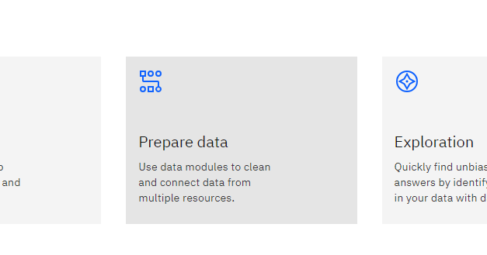

*Figure 2. Prepare data*

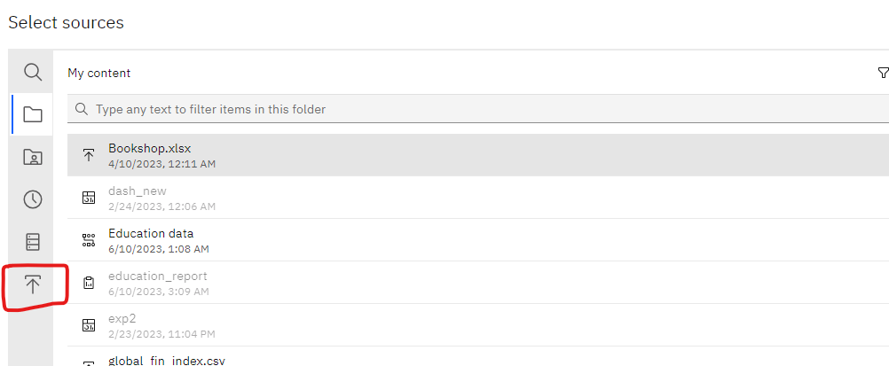

*Figure 3. Upload data in dashboard*

Once you upload the data into the data module, you will encounter the interface shown in the below image,

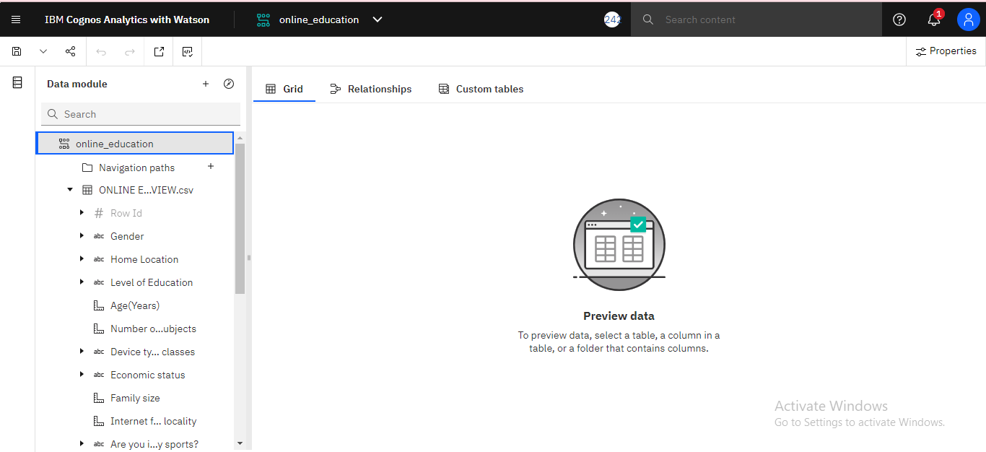

*Figure 4. Dashboard*

Remember to save this data in ‘My content’ section

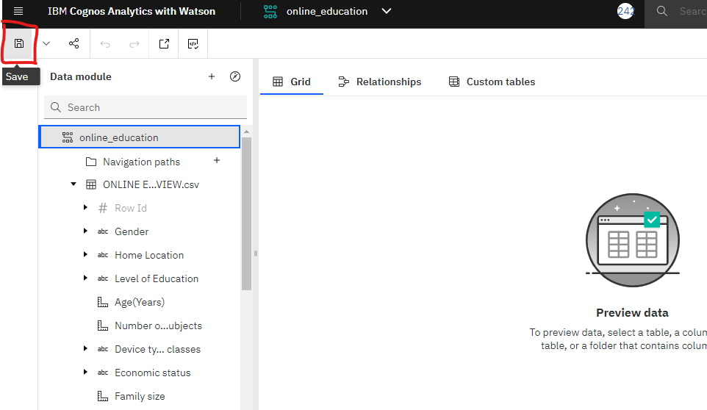

*Figure 5. Dashboard -save all details in my content*

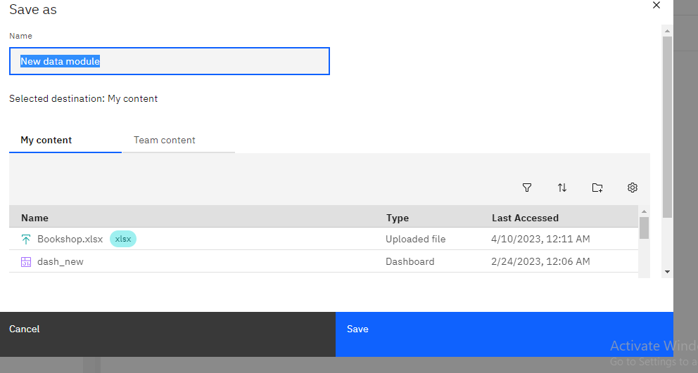

*Figure 6. Save the data as data module*

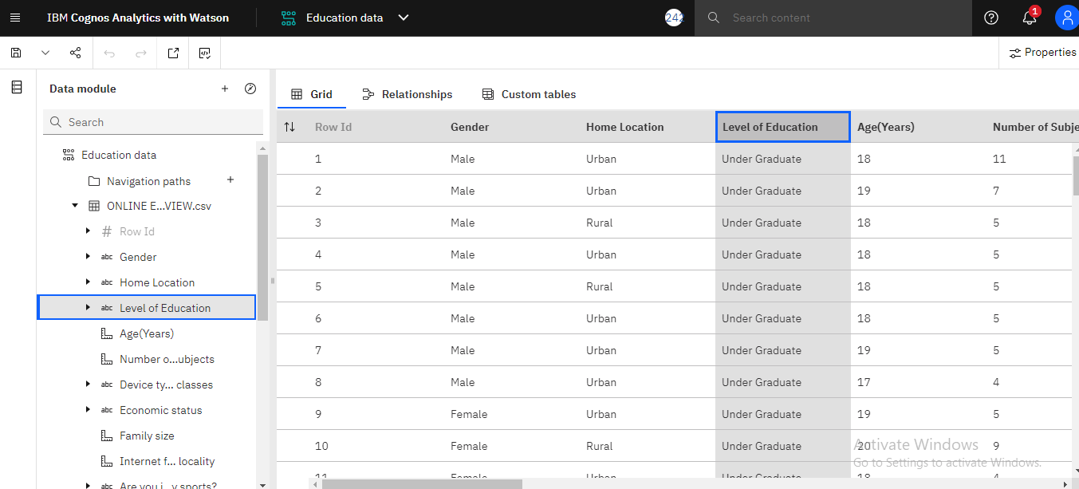

*Figure 7. To preview the data, double click any field in data module*

**5. Data Exploration**

Exploratory data analysis was conducted to gain preliminary insights into the data. Key findings from this phase encompassed:

• Identifying the most popular courses.

• Visualizing student engagement patterns.

• Exploring the relationship between instructor ratings and student performance.

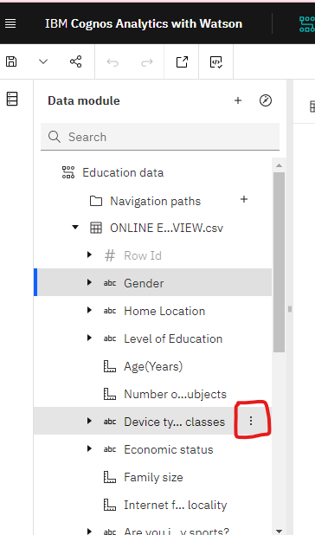 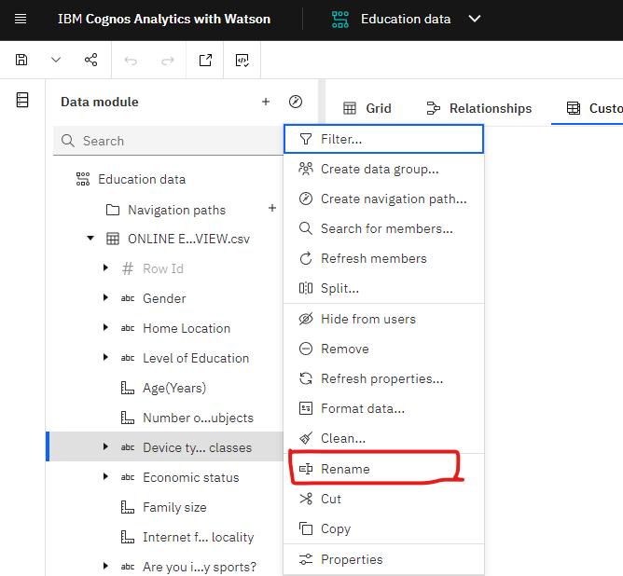

*Figure 8. Rename any field, click on the ‘three dots’ at the right side of the field*

**6. Data Analysis**

Advanced data analysis techniques, including machine learning models and predictive analytics, were applied to uncover deeper insights. This phase aimed to answer questions such as:

* Is online education beneficial for students?
* Do students perform better when they are learning virtually?
* Are students satisfied with online education?

If you want to change the ‘aggregation’ of any of the fields, click on the field for which you want to change the aggregation and then go to the properties option at the top right side of the screen

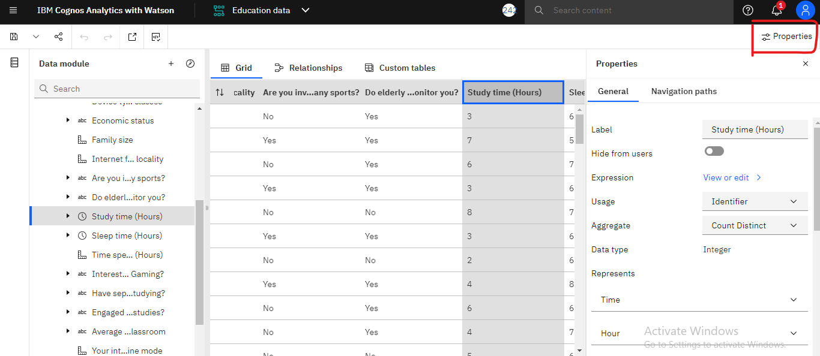

*Figure 9. Aggregation of fields in data file*

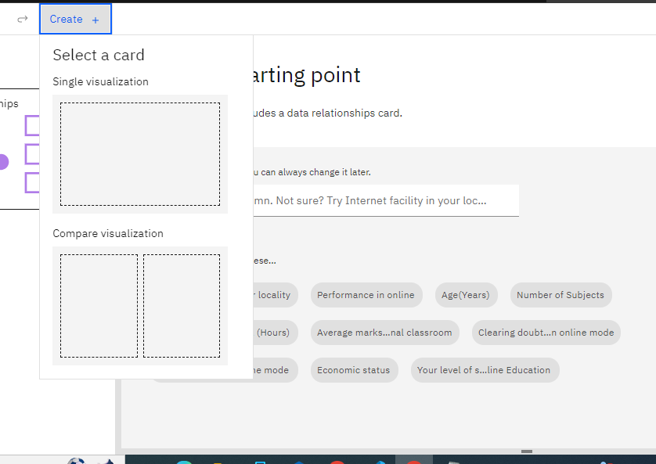

*Figure 10. Create a template for data visualization*

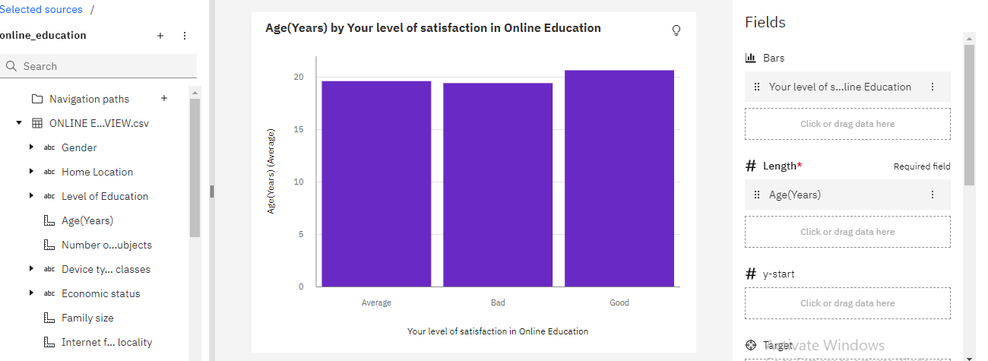

*Figure 11. A column bar chart between Your level of satisfaction in online education vs Age- sample data visualization*

**7. Key Findings**

The analysis unveiled several critical findings, including:

• Factors contributing to higher student engagement.

• Predictive indicators of student dropout.

• Effective teaching strategies associated with improved student performance.

• Opportunities for personalized learning experiences.

**8. Recommendations**

Based on the analysis, the following recommendations are offered:

• Implement personalized content delivery based on student preferences and engagement.

• Develop early warning systems to identify at-risk students.

• Enhance instructor training and support for effective online teaching.

• Invest in adaptive learning technologies for a tailored education experience.

**9. Conclusion**

In conclusion, this IBM Data Analytics project has shed light on the intricacies of the online education system. By implementing the recommendations, we can elevate the quality of online education, increase student success rates, and adapt to evolving educational needs.

**10. Appendices**

**Detailed code and scripts used for data analysis**

***Python Program app.py***

from flask import Flask, render_template

app = Flask(__name__)

@app.route("/")

def home():

return render_template(r"index.html")

if __name__ == "__main__":

app.run(debug=False, port=5000)

*Figure 12. Python Flask program for web integration*

**

* Template Name: Resi

* Updated: May 30 2023 with Bootstrap v5.3.0

* Template URL: https://bootstrapmade.com/resi-free-bootstrap-html-template/

* Author: BootstrapMade.com

* License: https://bootstrapmade.com/license/

*/

/*--------------------------------------------------------------

# General

--------------------------------------------------------------*/

body {

font-family: "Open Sans", sans-serif;

color: #444444;

}

a {

text-decoration: none;

color: #5a5af3;

}

a:hover {

color: #2a2af0;

text-decoration: none;

}

h1,

h2,

h3,

h4,

h5,

h6 {

font-family: "Raleway", sans-serif;

}

*Figure 13. A fraction of CSS code*

/**

* Template Name: Resi

* Updated: May 30 2023 with Bootstrap v5.3.0

* Template URL: https://bootstrapmade.com/resi-free-bootstrap-html-template/

* Author: BootstrapMade.com

* License: https://bootstrapmade.com/license/

*/

(function() {

"use strict";

/**

* Easy selector helper function

*/

const select = (el, all = false) => {

el = el.trim()

if (all) {

return [...document.querySelectorAll(el)]

} else {

return document.querySelector(el)

}

}

/**

* Easy event listener function

*/

const on = (type, el, listener, all = false) => {

let selectEl = select(el, all)

if (selectEl) {

if (all) {

selectEl.forEach(e => e.addEventListener(type, listener))

} else {

selectEl.addEventListener(type, listener)

}

}

}

*Figure 14. A fraction of Java Script*

**Additional visualizations, charts, and graphs**

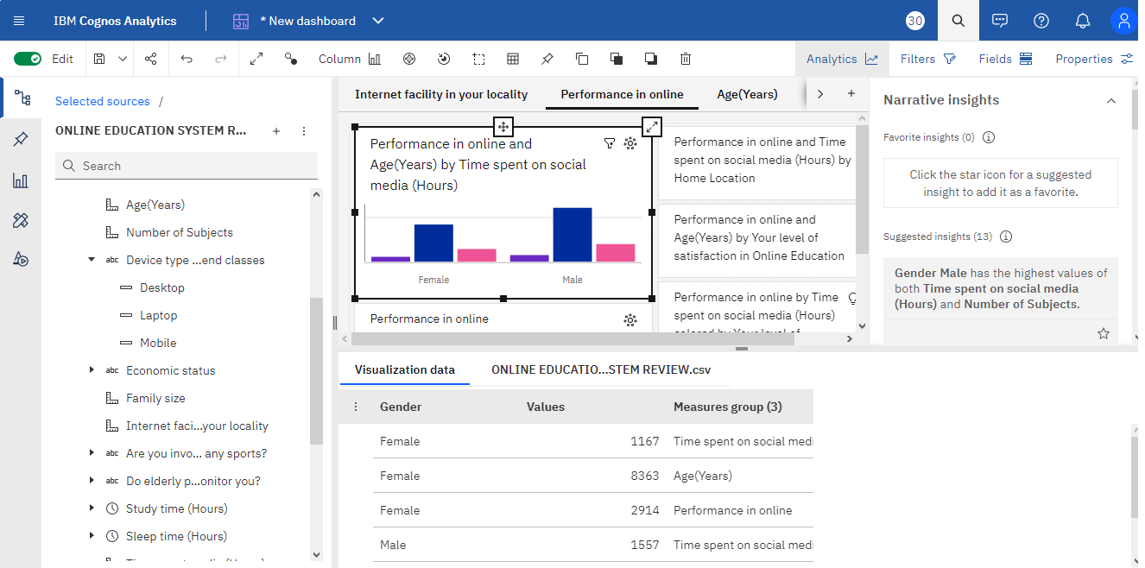

*Figure 15.a. Data Visualization – Tab 1*

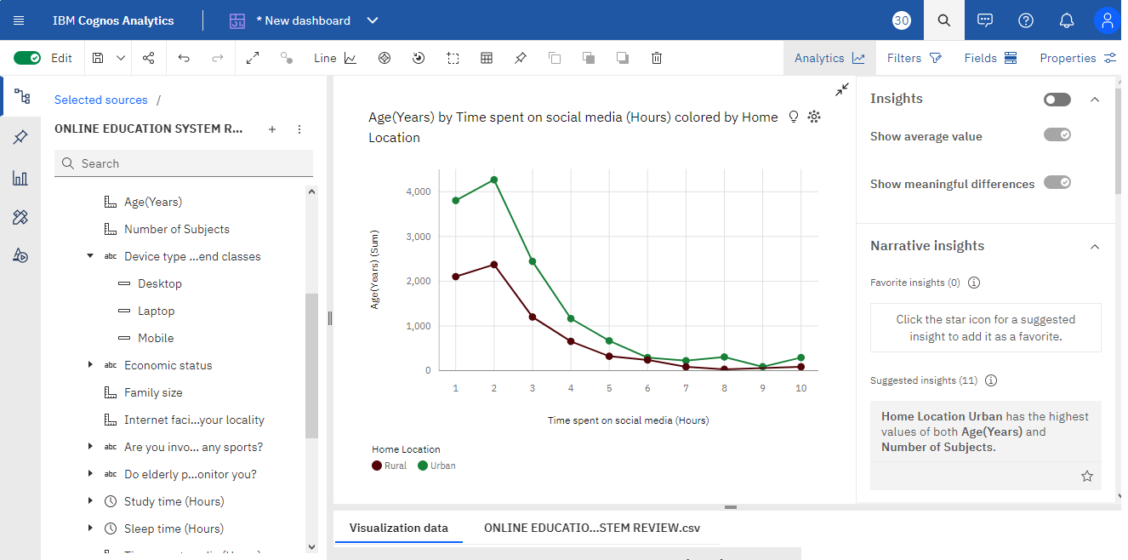

*Figure 15.b. Data Visualization – Tab 2*

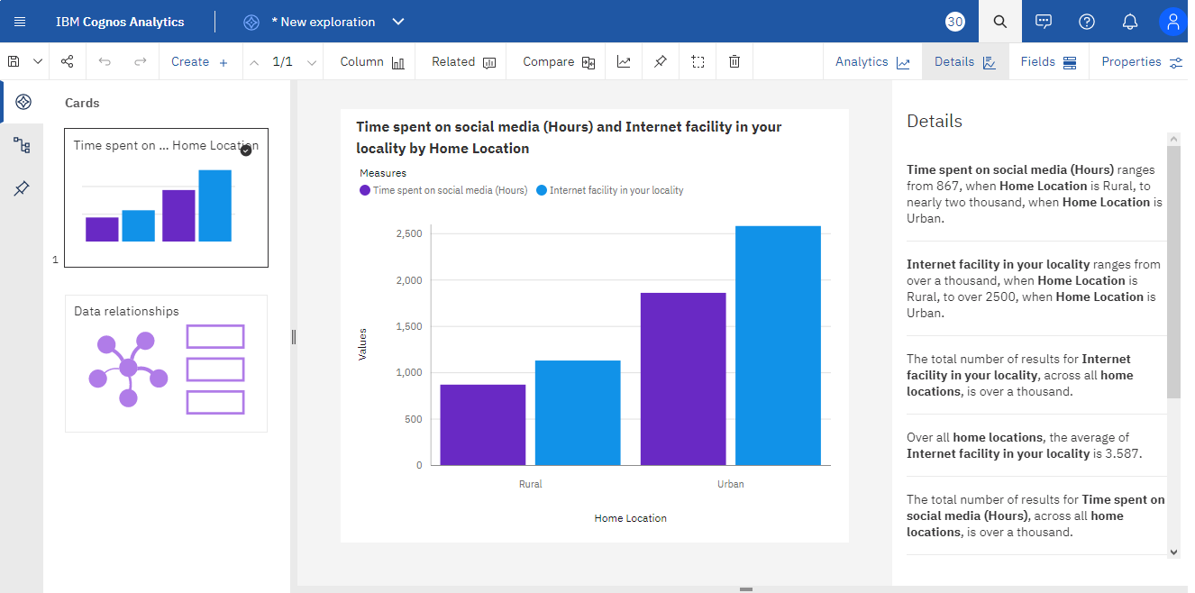

*Figure 15.c. Data Visualization – Tab 3*

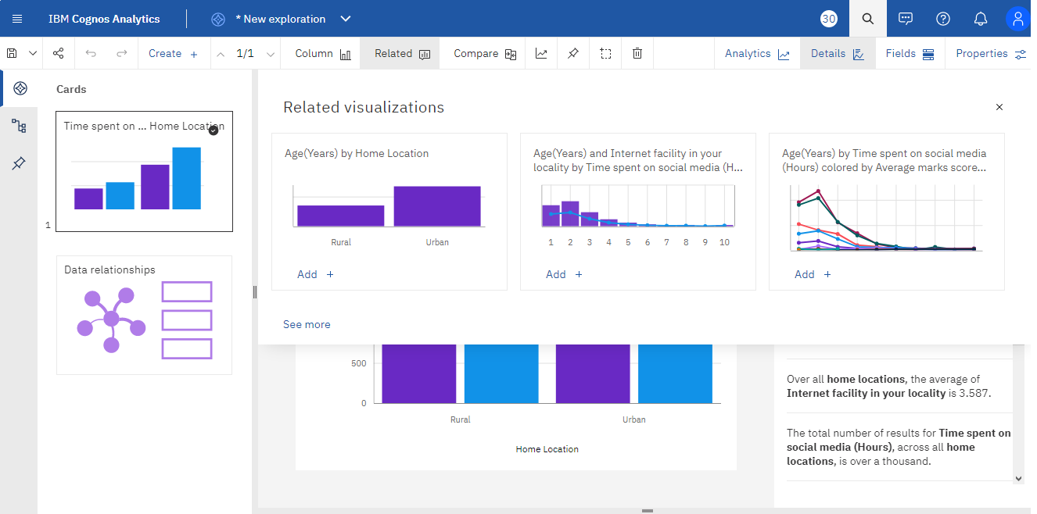

*Figure 15.d. Data Visualization – Tab 4*

**Any supplementary information relevant to the project**

**Story**

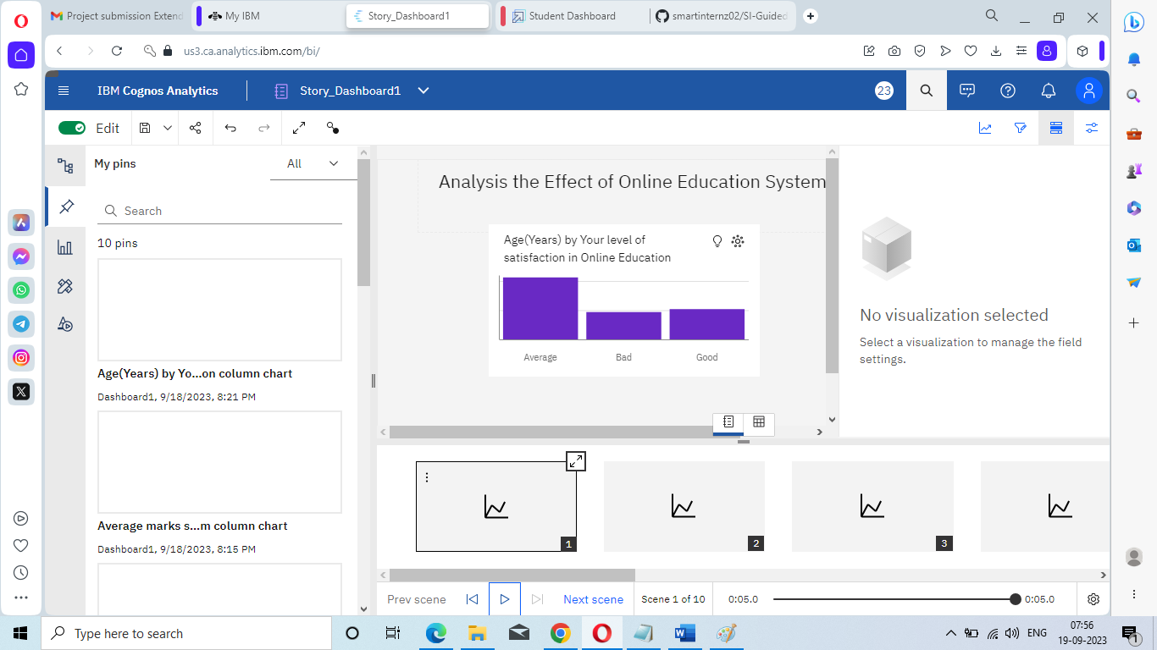

*Figure 16.a. Scene1*

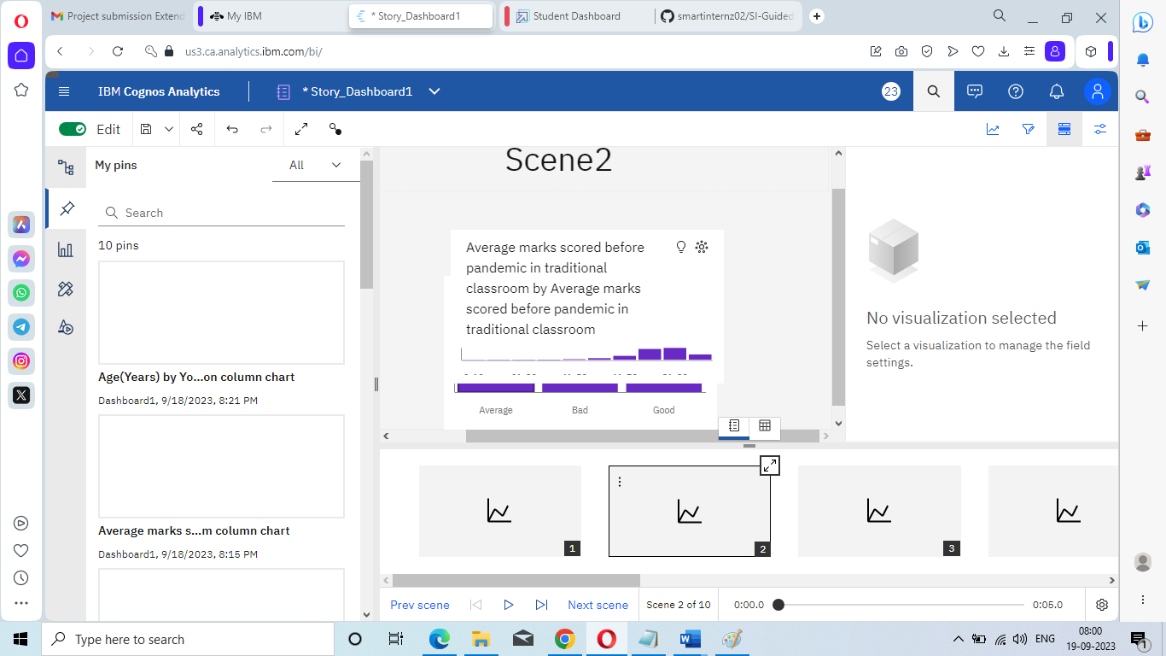

*Figure 16.b. Scene2*

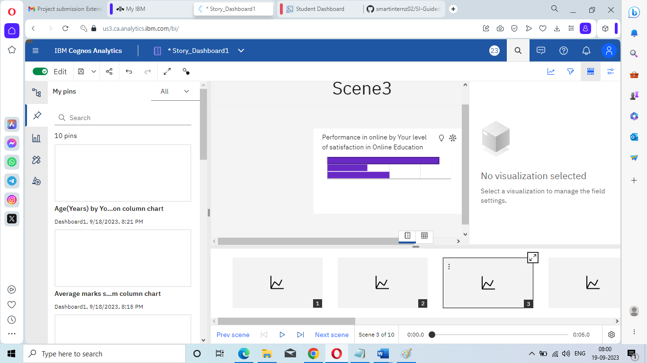

*Figure 16.c. Scene3*

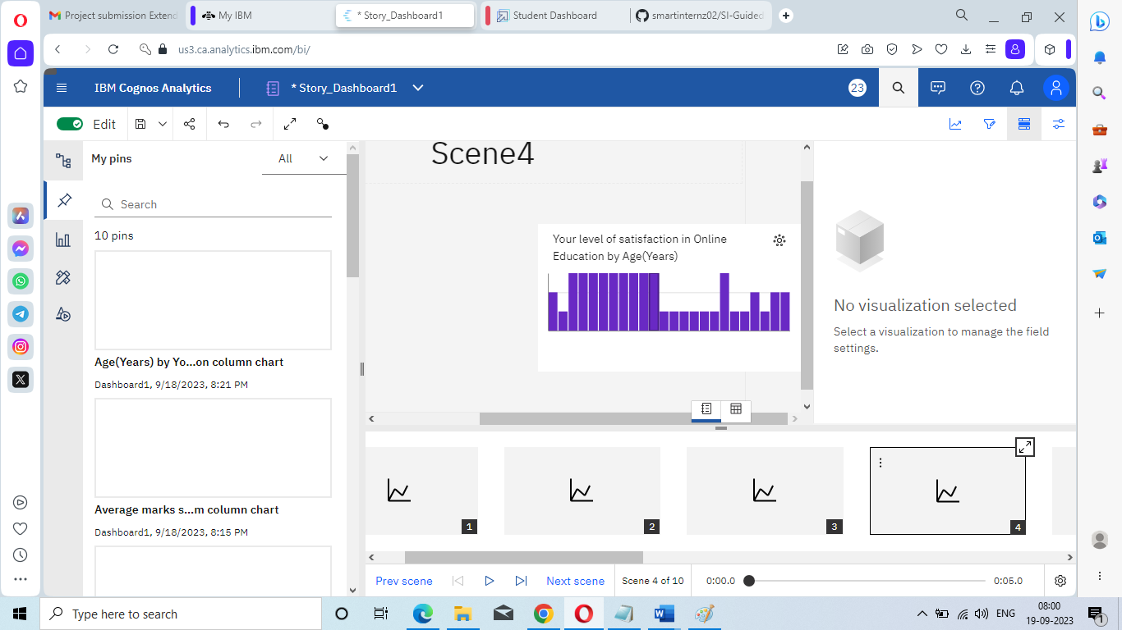

*Figure 16.d. Scene4*

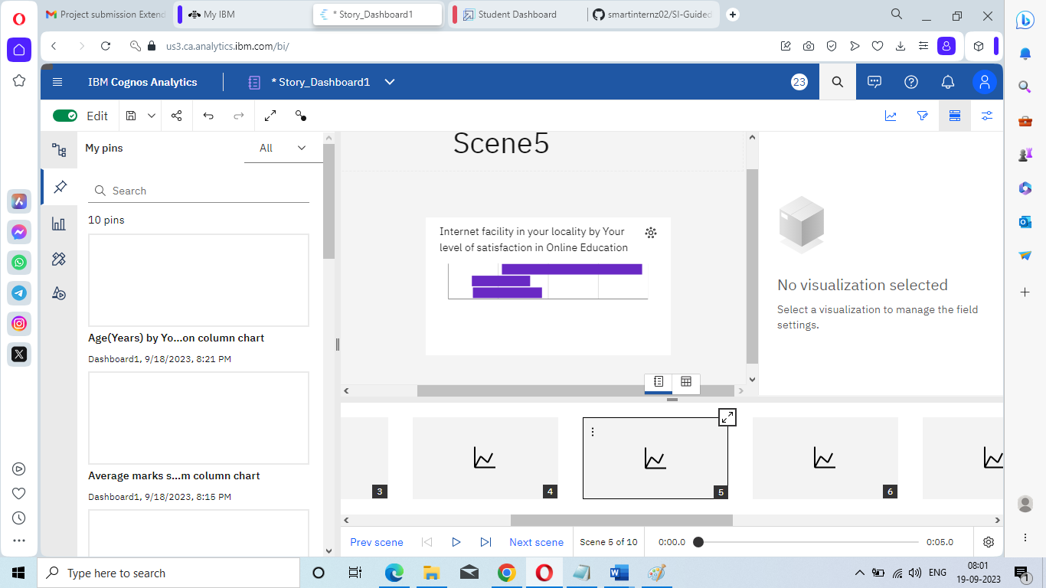

*Figure 16.e. Scene 5*

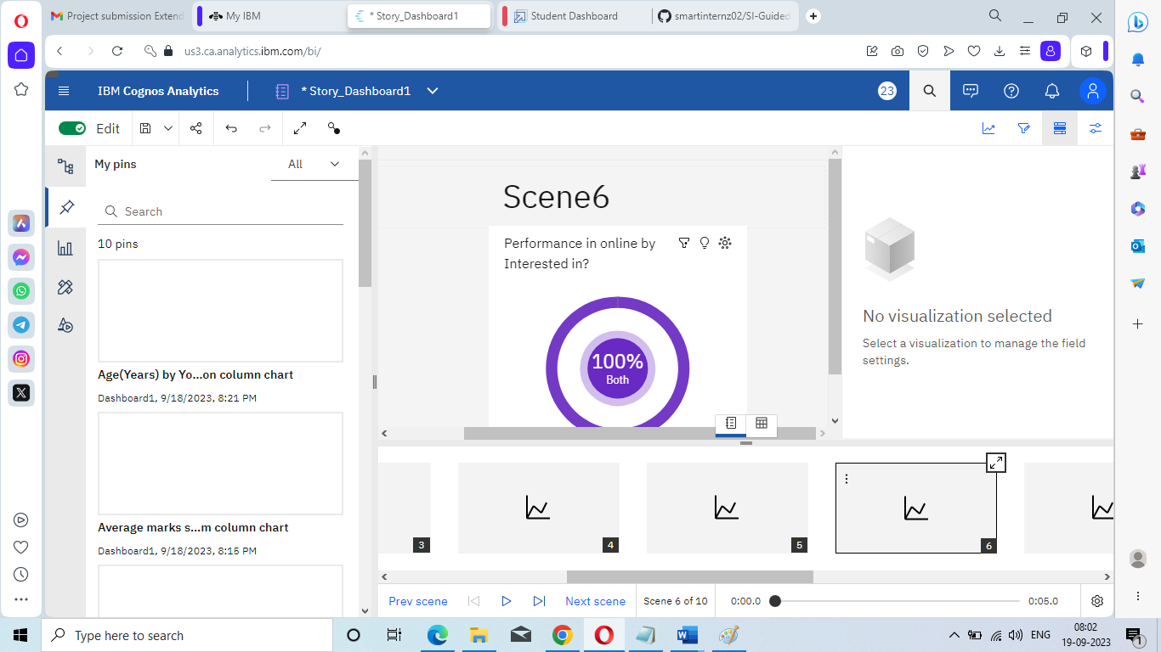

*Figure 16.f. Scene6*

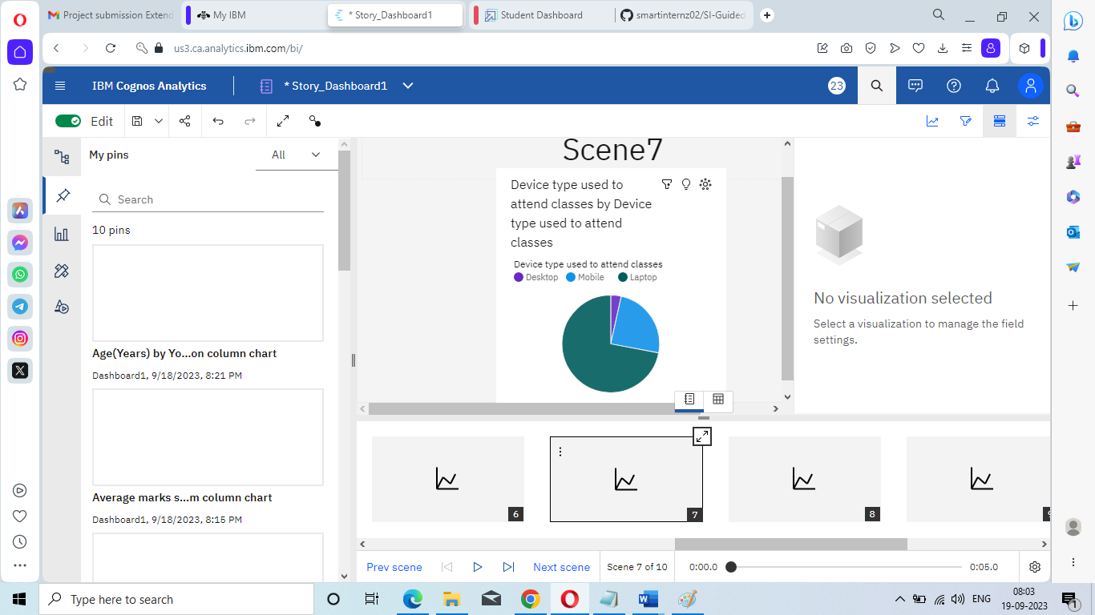

*Figure 16.g. Scene7*

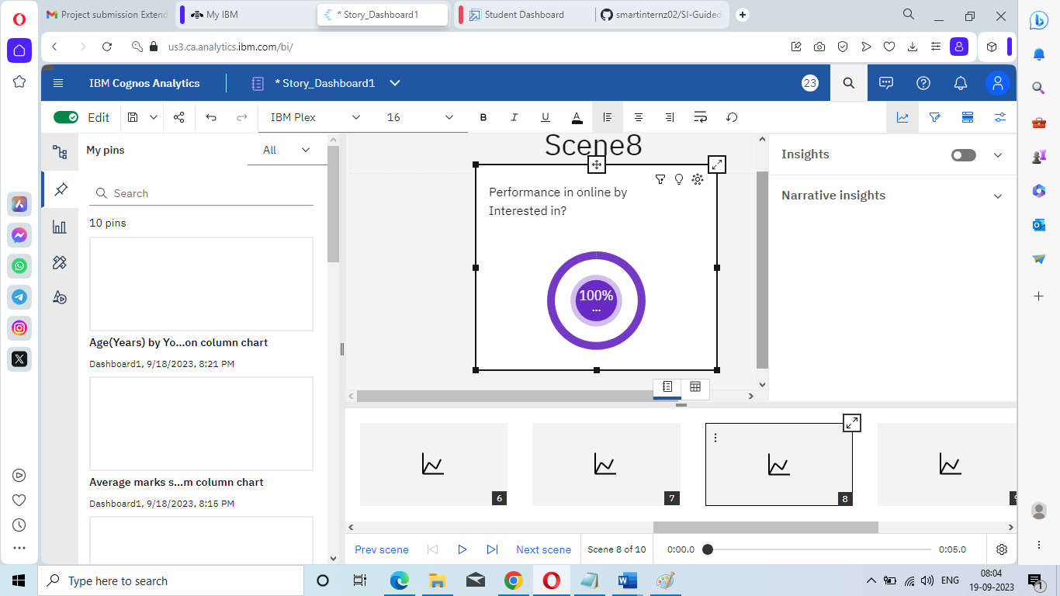

*Figure 16.h. Scene8*

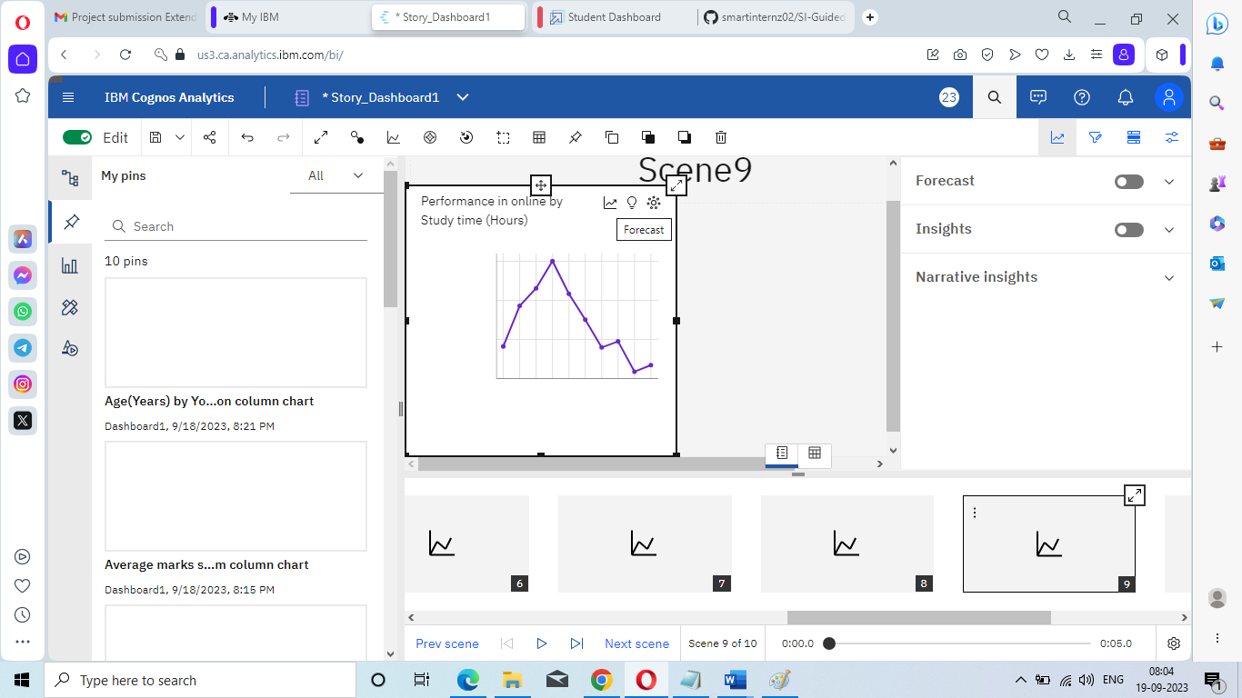

*Figure 16.i. Scene9*

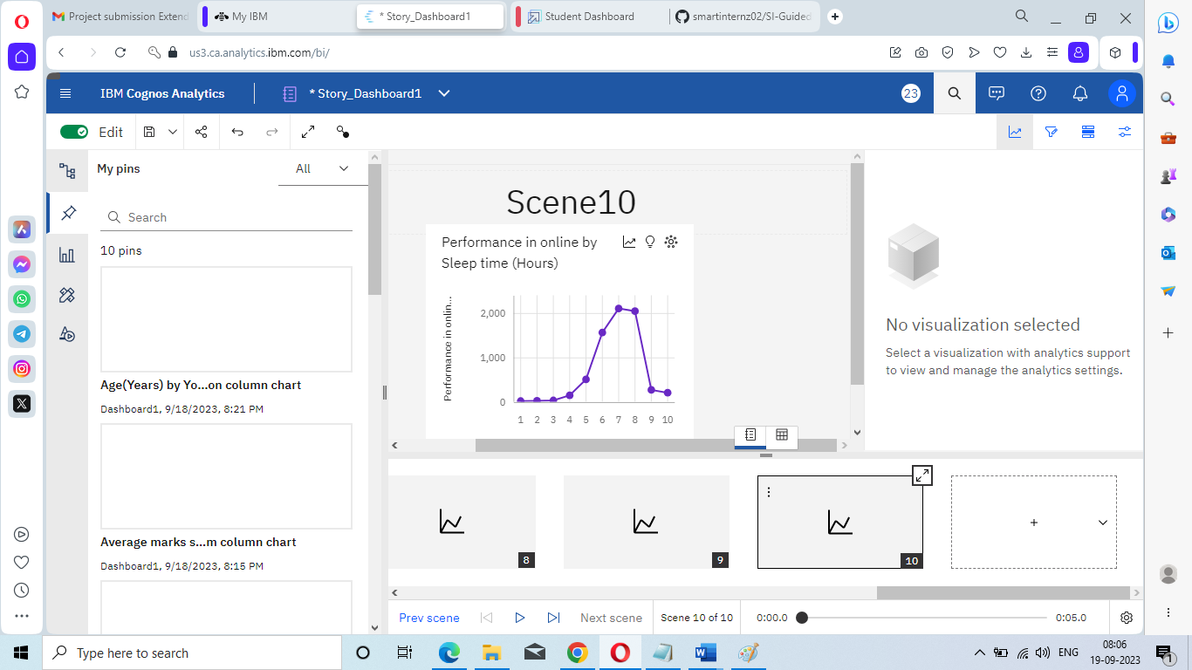

*Figure 16.j. Scene10*

**Report from Dashboard**

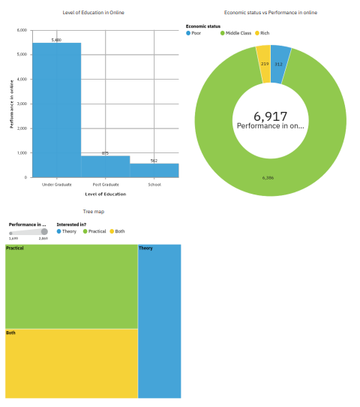

Figure 17. Report generated in my content